Apache POI API – We use apache POI API for excel data driven testing

Apache POI is a Java API for Microsoft documents. Using this API we can access excel documents, read data from them and write data to them.

Download Apache poi:

Go to google and search “Apache poi download” and download the zip folder and unzip it.

Note: If you use maven to run the tests, you don’t need to download anything. Just add the following maven dependencies and it will download everything.

poi-ooxml and poi

Now configure the build path and add the all the jar files downloaded.

Right click on the project, go to build path and configure build path and go to libraries and click on add external jars and add the above two files.

Now create a separate folder under the project with name “data” and store the excel file you have created.

Steps:

* Create object for XSSFWorkbook class
* Get access to sheet
* Get access to all rows of sheet
* Access to specific row from all rows
* Get access to all cells of Row
* Access the data from cells into Arrays

**Sample:**

Data Sheet:

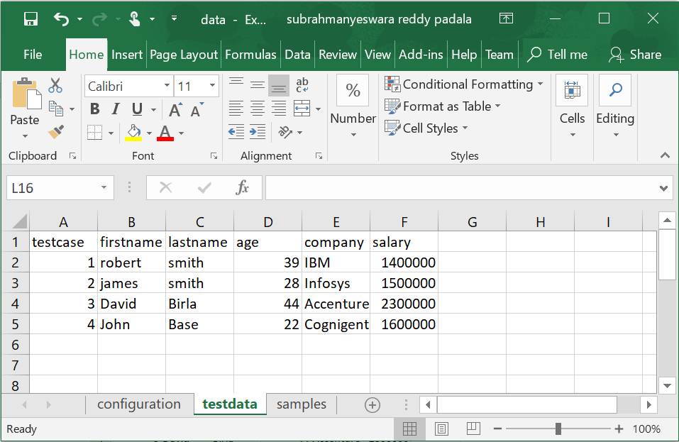

**package** ExcelTesting;

**import** java.io.FileInputStream;

**import** java.io.FileNotFoundException;

**import** java.io.IOException;

**import** java.util.Iterator;

**import** org.apache.poi.ss.usermodel.Cell;

**import** org.apache.poi.ss.usermodel.Row;

**import** org.apache.poi.xssf.usermodel.XSSFSheet;

**import** org.apache.poi.xssf.usermodel.XSSFWorkbook;

**public** **class** ExcelReadingBasic {

**public** **static** **void** main(String[] args) **throws** IOException {

//Get access to the workbook

FileInputStream fis = **new** FileInputStream("./data/data.xlsx");

XSSFWorkbook workbook = **new** XSSFWorkbook(fis);

//Get the sheet you want

XSSFSheet sheet = workbook.getSheet("testdata");

//Get a row number

Row row = sheet.getRow(1);

//Get a cell number

Cell cell = row.getCell(1);

//Get that cell value

System.***out***.println(cell.getStringCellValue());

workbook.close();

}

}